Progressive Report

Dingming

1. Background

The target of analysis is switched to focus on simpler indicators and some findings based on these indicators:

**Retrace Date: the date when the price reaches maximum/minimum**

**Peak Gain/Trough loss: Peak gain/Trough loss from day0**

**Recover Date: the date when the price recovers to day0**

**Mix of stock recovered: the mix of stocks which can recover to day0**

**Mix of stock monotonic: the mix of stocks which have monotonic trends**

1. Data

I set the model as the following parameters:

1. Observe **20** days after earnings
2. Earnings over **10%** beat and over **10%** miss are calculated
3. **Semiconductor**, **59** stocks in total, U.S(**19**), EU(**13**), Asia Pacific Developed(13), Asia Pacifica Merging(**14**), All selected stocks are among the top-ranked by market capitalization.
4. Results

**Key Takeaways:**

a. Stock always retrace when miss down and is more likely to show monotonic trends when beat up.

b. When beat up, stock is more likely to retrace on day 1-2, then day 6, then day 10. For beat down situation, stock usually retrace on day 4.

c. There’s a positive relationship between Peak gain/Trough loss and retrace date.

d. For all situations, the mix of stock recovered to day 0 is about 50%, and the time it takes to recover has a positive relationship with the time it retrace.

**Distribution of the four situations**

The distribution of the four situations is shown in the below figures:

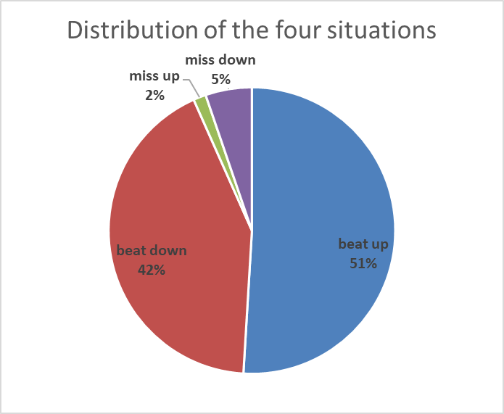



Beats are 10 times more than misses. There’s almost no miss up in semi-conductor.

Beat up has more samples that not retrace(monotonic trends), indicating that the stock is more likely to continuously increase without dropping in this situation.

Stocks of miss down always retrace.

**Number of days to retrace**

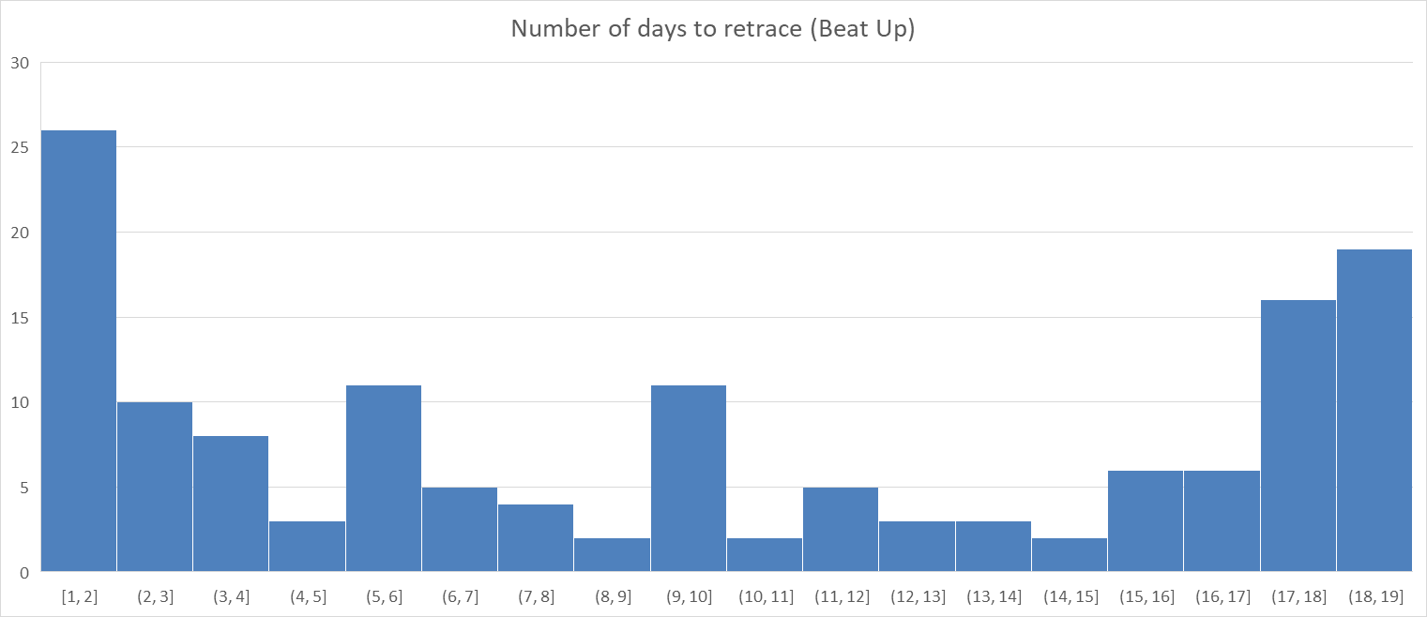

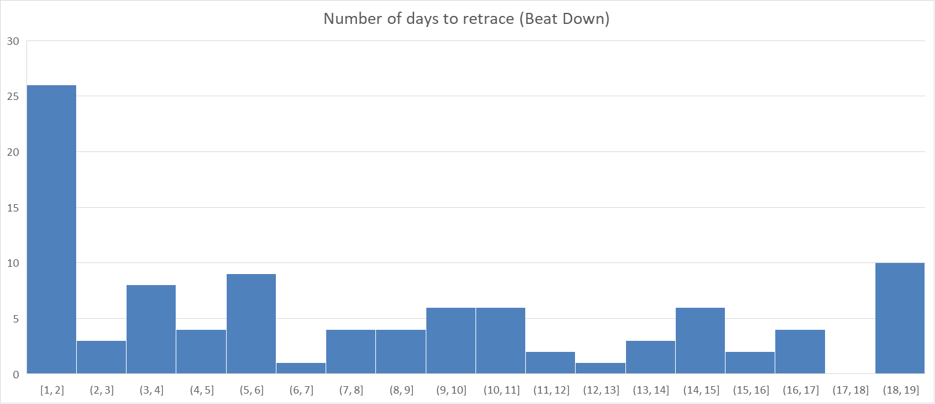

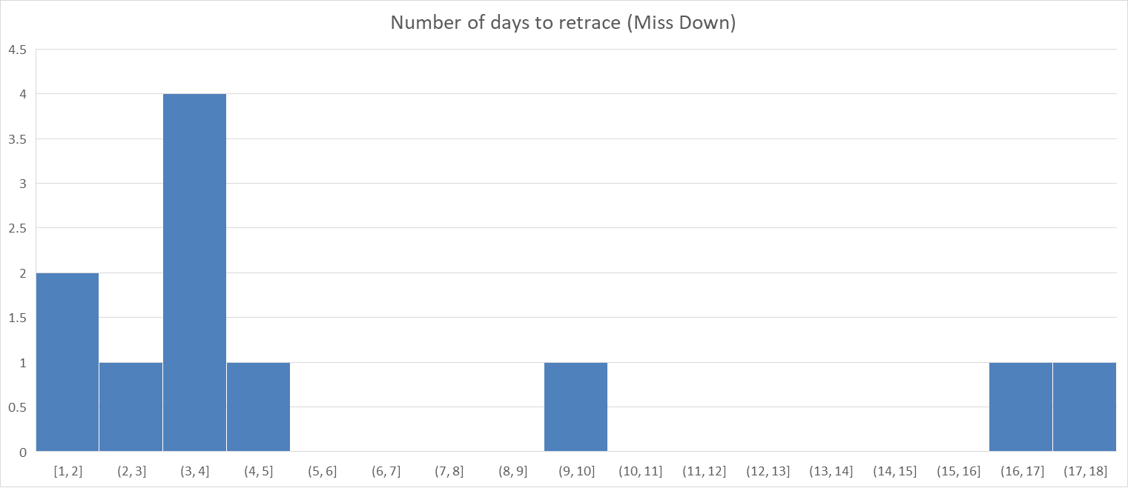

From the figure of beat-up, it can be observed that there are 3 peaks, and it follows a step-like pattern. It indicates that if the stock price does not retrace after day1 or day2, it is more likely to retrace on day 6, then day 10.

For Beat-down situation, the stock is more likely to retrace on day1 or day2 after earnings.

For miss-up situation, the sample size is so small that it could not provide useful insights.

For miss-down, retrace is more likely to happen on day 4.

The red square shows that beats within this square reach their maximum price around day 18-20, suggesting that these beats are monotonically increasing (the outliers that we have previously discussed). In the following calculation and the analysis, I eliminated these outliers and only calculate those who “actually retrace”

**Peak Gain & Trough Loss**

The average Peak Gain/Trough Loss is calculated based on the retrace date. The result is as shown in the following figure.



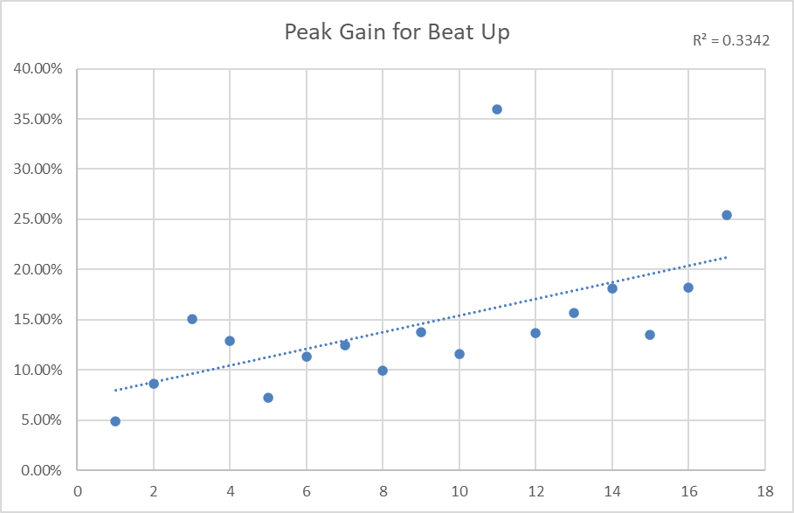

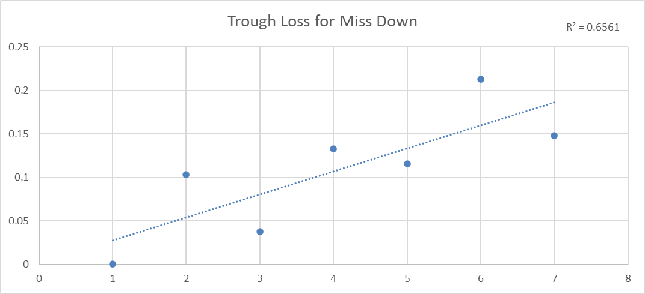

The average Peak Gain and Trough Loss shows positive relationship with retrace date. It offers us some insight to determine whether the stock would retrace certain days after the earnings. For example, in beat up situation if a stock continuously show higher gain than the average level, then we could suppose that this stock has high possibility to retrace at any time.

**Mix of stock recovered & Recover Period**

The recovery rate of beat up is 49.53%, 56.18% for beat down and 54.55% for miss down. It indicates that 50% of the stocks will recover within 20 days.

I compare the retrace date and how long does it take to recover to day0 (recover period). There’s a slightly positive relationship between how long it takes to retrace and to recover to day 0. An estimate can be made to predict how long it would take to recover when the stock starts to retrace.

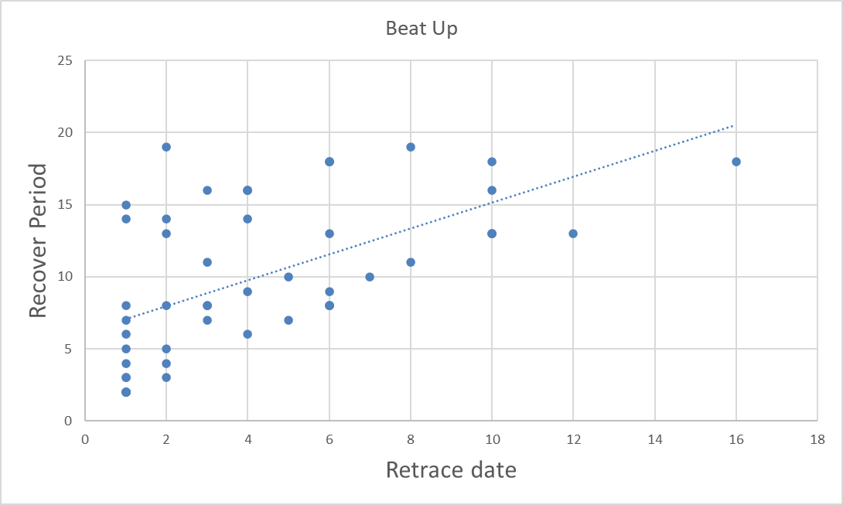



**Surprise & Peak Gain/Trough Loss & Retrace Date**

According to the correlation matrix below, surprise has little correlation with Peak gain/Trough loss and retrace date. However, Peak gain/trough loss has correlation with retrace date.



